**Step by Step Guide on Installing Oracle Database 11g on Windows 10**

This is a step by step guide on how to install Oracle Database on windows 10 64 bit. Oracle Database 11g have new features than it previous version Oracle 11g brings dream closer to reality there are many new features added in Oracle Database 11g like **Database Replay tool** with database replay tool we can capture our production database and replay it on test database to test changes, Over all database infrastructure with Oracle Database 11g is more resilient, manageable, and efficient.

To install Oracle Database on windows 10 first download Oracle 11g 64 bit from Oracle please follow link given below to download [Oracle Database 11g](http://www.oracle.com/technetwork/database/enterprise-edition/downloads/index.html)

<http://www.oracle.com/technetwork/database/enterprise-edition/downloads/index.html>

After Oracle Database 11g download complete extract zip files then run setup.exe from installation folder.

[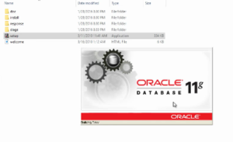](http://thetechnosolution.com/wp-content/uploads/2016/08/Oracle-11g-installation.png)

Select C**reate and configure database**

[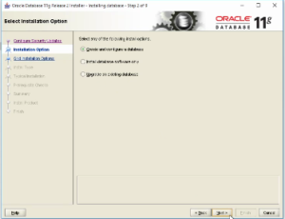](http://thetechnosolution.com/wp-content/uploads/2016/08/Oracle-11g-installation-1.png)

Select **Desktop Class** then click on next for next step

[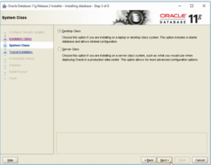](http://thetechnosolution.com/wp-content/uploads/2016/08/Oracle-11g-installation-2.png)

Choose installation path where you want to install Oracle Database 11g after that enter database name and admin password for your database

[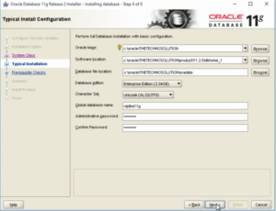](http://thetechnosolution.com/wp-content/uploads/2016/08/Oracle-11g-installation-3.png)

Click finish to start Oracle Database installation

[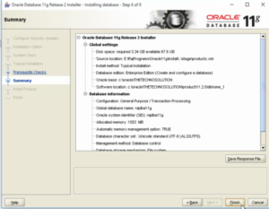](http://thetechnosolution.com/wp-content/uploads/2016/08/Oracle-11g-installation-4.png)

Oracle Database installation is started

[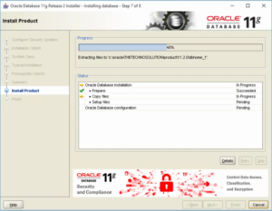](http://thetechnosolution.com/wp-content/uploads/2016/08/Oracle-11g-installation-5.png)

Click in **Allow access**when prompted

[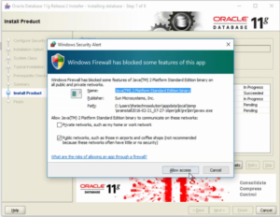](http://thetechnosolution.com/wp-content/uploads/2016/08/Oracle-11g-installation-6.png)

[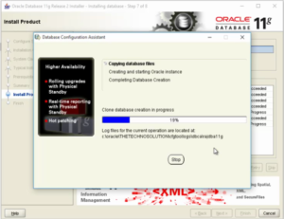](http://thetechnosolution.com/wp-content/uploads/2016/08/Oracle-11g-installation-7.png)

Installing Oracle Database 11g on windows 10 is almost completed you can see information about Oracle Database name, system identifier(SID) and the URL to open or access Oracle Database on this page click OK to continue

[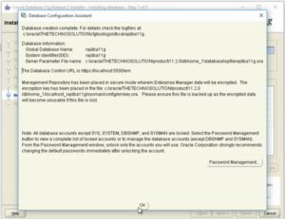](http://thetechnosolution.com/wp-content/uploads/2016/08/Oracle-11g-installation-8.png)

Click finish here Oracle Database 11g is installed on windows 10.

[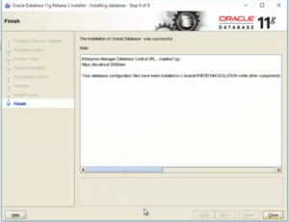](http://thetechnosolution.com/wp-content/uploads/2016/08/Oracle-11g-installation-9.png)

Now you can use Oracle Database 11g on windows, You can manage you database through URL to open **OracleDBConsole**type <https://localhost:1158/em> in web browser in user name type SYS and in password enter same password you entered at the time of Oracle Database 11g installation and Select **SYSDBA** in Connect as field. You can also access Oracle Database by running command **SQLPLUS.**

**In the username you can also type system and then password as oracle.**

UBUNTU

Step 1: [Download](http://www.oracle.com/technetwork/database/database-technologies/express-edition/downloads/index.html) Oracle Database Express Edition.

Step 2: Instructions before install Oracle

1. Copy the downloaded file and paste it in home directory.
2. Unzip using the command:
3. unzip oracle-xe-11.2.0-1.0.x86_64.rpm.zip
4. Install required packages using the command:
5. sudo apt-get install alien libaio1 unixodbc
6. Enter into the Disk1 folder using command:
7. cd Disk1/
8. Convert RPM package format to DEB package format (that is used by Ubuntu) using the command:
9. sudo alien --scripts -d oracle-xe-11.2.0-1.0.x86_64.rpm
10. Create the required chkconfig script using the command:
11. sudo pico /sbin/chkconfig

The pico text editor is started and the commands are shown at the bottom of the screen. Now copy and paste the following into the file and save:

#!/bin/bash

# Oracle 11gR2 XE installer chkconfig hack for Ubuntu

file=/etc/init.d/oracle-xe

if [[ ! `tail -n1 $file | grep INIT` ]]; then

echo >> $file

echo '### BEGIN INIT INFO' >> $file

echo '# Provides: OracleXE' >> $file

echo '# Required-Start: $remote_fs $syslog' >> $file

echo '# Required-Stop: $remote_fs $syslog' >> $file

echo '# Default-Start: 2 3 4 5' >> $file

echo '# Default-Stop: 0 1 6' >> $file

echo '# Short-Description: Oracle 11g Express Edition' >> $file

echo '### END INIT INFO' >> $file

fi

update-rc.d oracle-xe defaults 80 01

1. Change the permission of the chkconfig file using the command:
2. sudo chmod 755 /sbin/chkconfig
3. Set kernel parameters. Oracle 11gR2 XE requires additional kernel parameters which you need to set using the command:
4. sudo pico /etc/sysctl.d/60-oracle.conf
5. Copy the following into the file and save:
6. # Oracle 11g XE kernel parameters
7. fs.file-max=6815744
8. net.ipv4.ip_local_port_range=9000 65000
9. kernel.sem=250 32000 100 128
10. kernel.shmmax=536870912
11. Verify the change using the command:
12. sudo cat /etc/sysctl.d/60-oracle.conf
13. You should see what you entered earlier. Now load the kernel parameters:
14. sudo service procps start
15. Verify the new parameters are loaded using:
16. sudo sysctl -q fs.file-max

You should see the file-max value that you entered earlier.

1. Set up /dev/shm mount point for Oracle. Create the following file using the command:
2. sudo pico /etc/rc2.d/S01shm_load
3. Copy the following into the file and save.
4. #!/bin/sh
5. case "$1" in
6. start)
7. mkdir /var/lock/subsys 2>/dev/null
8. touch /var/lock/subsys/listener
9. rm /dev/shm 2>/dev/null
10. mkdir /dev/shm 2>/dev/null
11. *)
12. echo error
13. exit 1
14. ;;
15. esac
16. Change the permissions of the file using the command:
17. sudo chmod 755 /etc/rc2.d/S01shm_load
18. Now execute the following commands:
19. sudo ln -s /usr/bin/awk /bin/awk
20. sudo mkdir /var/lock/subsys
21. sudo touch /var/lock/subsys/listener

Now, Reboot Your System

Step 3: Install Oracle

1. Install the oracle DBMS using the command:
2. sudo dpkg --install oracle-xe_11.2.0-2_amd64.deb
3. Configure Oracle using the command:
4. sudo /etc/init.d/oracle-xe configure
5. Setup environment variables by editting your .bashrc file:
6. pico ~/.bashrc
7. Add the following lines to the end of the file:
8. export ORACLE_HOME=/u01/app/oracle/product/11.2.0/xe
9. export ORACLE_SID=XE
10. export NLS_LANG=`$ORACLE_HOME/bin/nls_lang.sh`
11. export ORACLE_BASE=/u01/app/oracle
12. export LD_LIBRARY_PATH=$ORACLE_HOME/lib:$LD_LIBRARY_PATH
13. export PATH=$ORACLE_HOME/bin:$PATH
14. Load the changes by executing your profile:
15. . ~/.bashrc
16. Start the Oracle 11gR2 XE:
17. sudo service oracle-xe start
18. Add user YOURUSERNAME to group dba using the command:
19. sudo usermod -a -G dba YOURUSERNAME

Step 4: Using the Oracle XE Command Shell

1. Start the Oracle XE 11gR2 server using the command:
2. sudo service oracle-xe start
3. Start command line shell as the system admin using the command:
4. sqlplus sys as sysdba

Enter the password that you gave while configuring Oracle earlier. You will now be placed in a SQL environment that only understands SQL commands.

1. Create a regular user account in Oracle using the SQL command:
2. create user USERNAME identified by PASSWORD;

Replace USERNAME and PASSWORD with the username and password of your choice. Please remember this username and password. If you had error executing the above with a message about resetlogs, then execute the following SQL command and try again:

Alter database open resetlogs;

1. Grant privileges to the user account using the SQL command:
2. grant connect, resource to USERNAME;

Replace USERNAME and PASSWORD with the username and password of your choice. Please remember this username and password.

1. Exit the sys admin shell using the SQL command:
2. exit;
3. Start the command line shell as a regular user using the command:
4. sqlplus

Now, you can run sql commands...